**CMPG 323 Deliverable 1**

**Documentation**

**-**

**John Redman**

**34341129**

**The Academic Weapons**

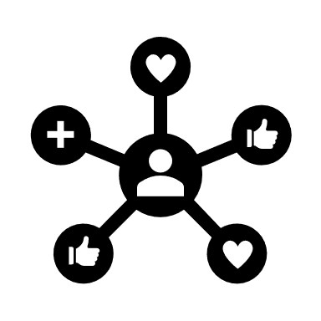

**Overview**

Deliverable 1 consisted of multiple parts, namely creating full-fledged GitHub and LinkedIn accounts as well as creating and hosting a fully functional virtual CV. My virtual CV can be found under <https://john-redman.github.io/> . My virtual presence can be explored with the following links:

* GitHub: <https://github.com/john-redman>
* LinkedIn: <https://www.linkedin.com/in/john-redman-0b7694237/>

**Technologies Used**

* HTML
* CSS
* Font Awesome for CSS
* Visual Studio Code
* GitHub & GitHub Desktop

**Hosting**

My CV was hosted on GitHub Pages, chosen for its ease of use and cheapness. Pages’ preexisting integration into GitHub also made it easier to add changes into production, saving valuable time.

**Innovation**

The use of CSS made it easy to change the look of my page as I pleased without too much hassle. All elements on the page are neatly and precisely placed, without worrying about formatting issues.

**Visual Appeal**

My website utilizes a minimalist style paired with sleek, modern designs and colours for a refreshing look. A constant house-style was adhered to and no out-of-place elements are visible on the page.

**Web Technologies**

This project utilizes HTML5 and CSS, used for styling. Hosting is done on GitHub Pages.

Font Awesome, imported into HTML, was used for all the icon-elements seen on the page. The rotate function was also used to rotate the images under the “Skillset” section when the mouse hovers over them to add to the interactive “feel” of the page.

The “Get Resume” button allows the user to download a PDF copy of my resume.

**Compatibility**

The hosted CV is compatible with most PC and widescreen devices, however more attention could be given to the mobile version. Enough empty space is given to account for different screen sizes, despite them possibly having the same aspect ratio’s.

**Navigation**

The virtual CV functions as a single page and navigates linearly. The navigation bar at the top, however, is always visible on screen and its buttons can also be used to jump to different sections.

The “Hire Me” button jumps the user to the “Contact” section of the page, where my immediate contact details are readily available.